MANGINSAY, Eulan Angelika R.

2-ECE-E

1. isWordGuessed

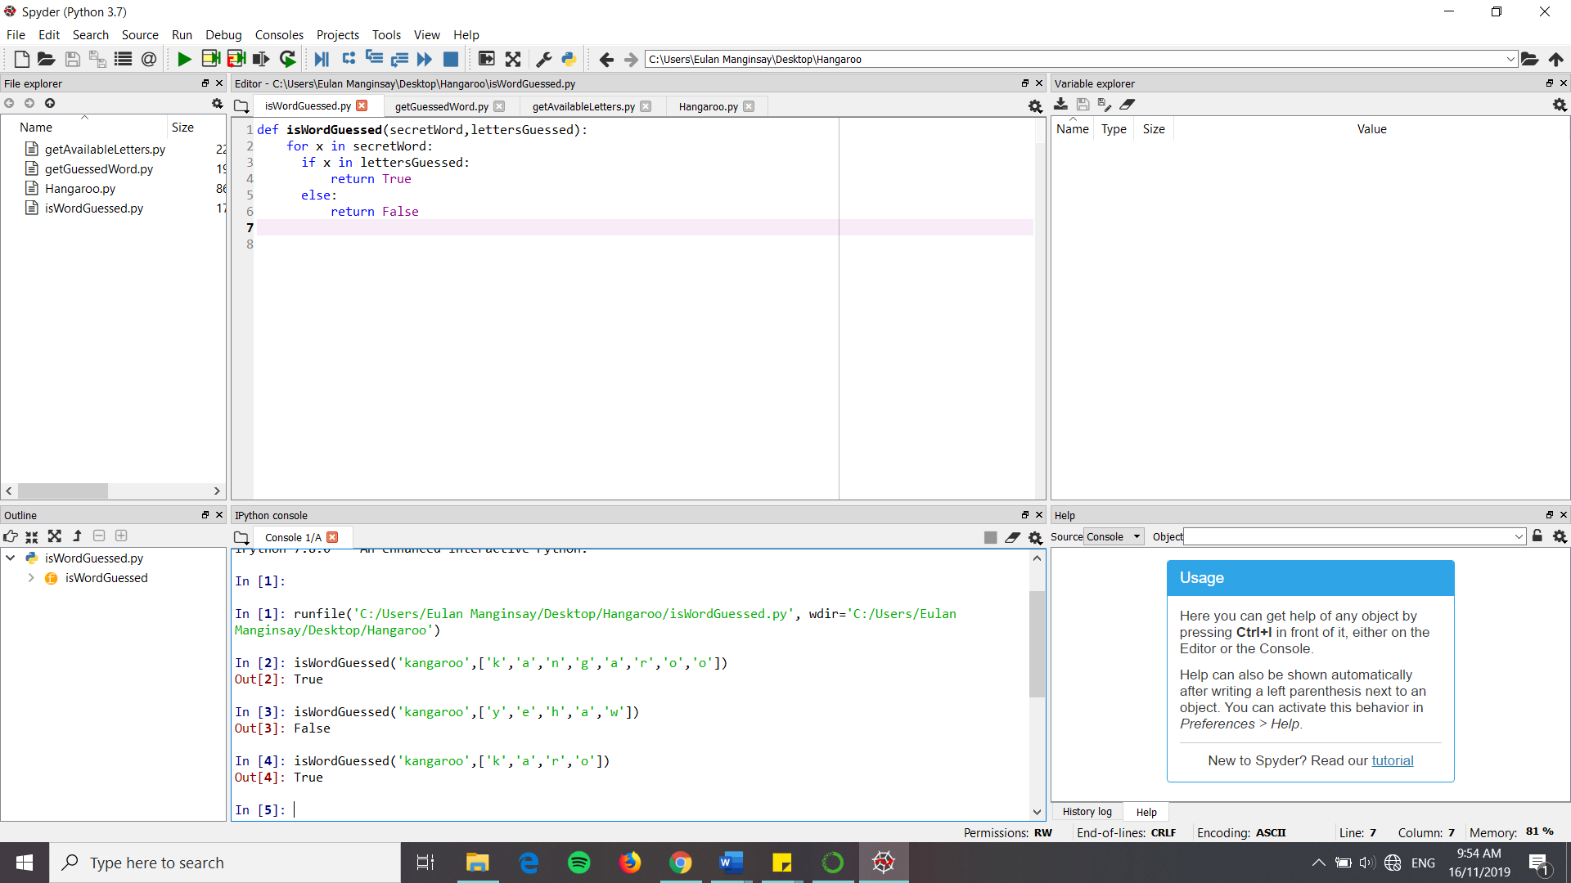

2. getGuessedWord

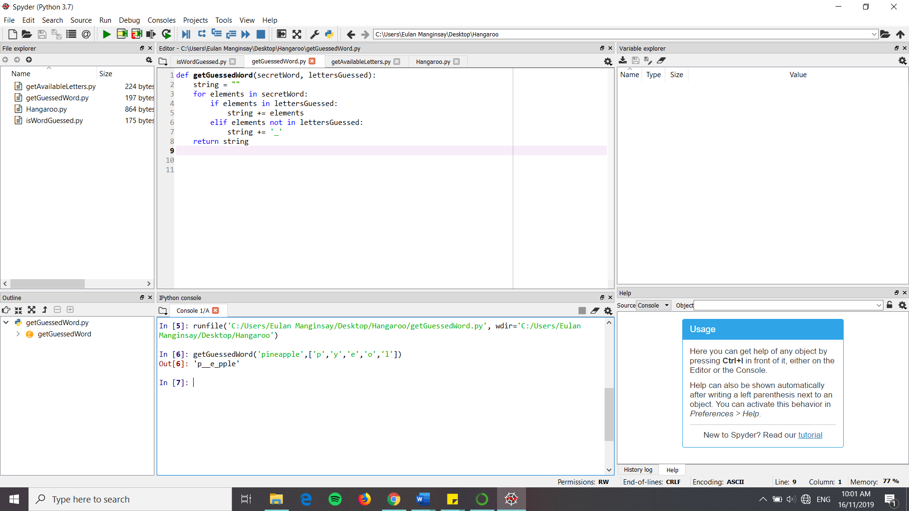

3. getAvailableLetters

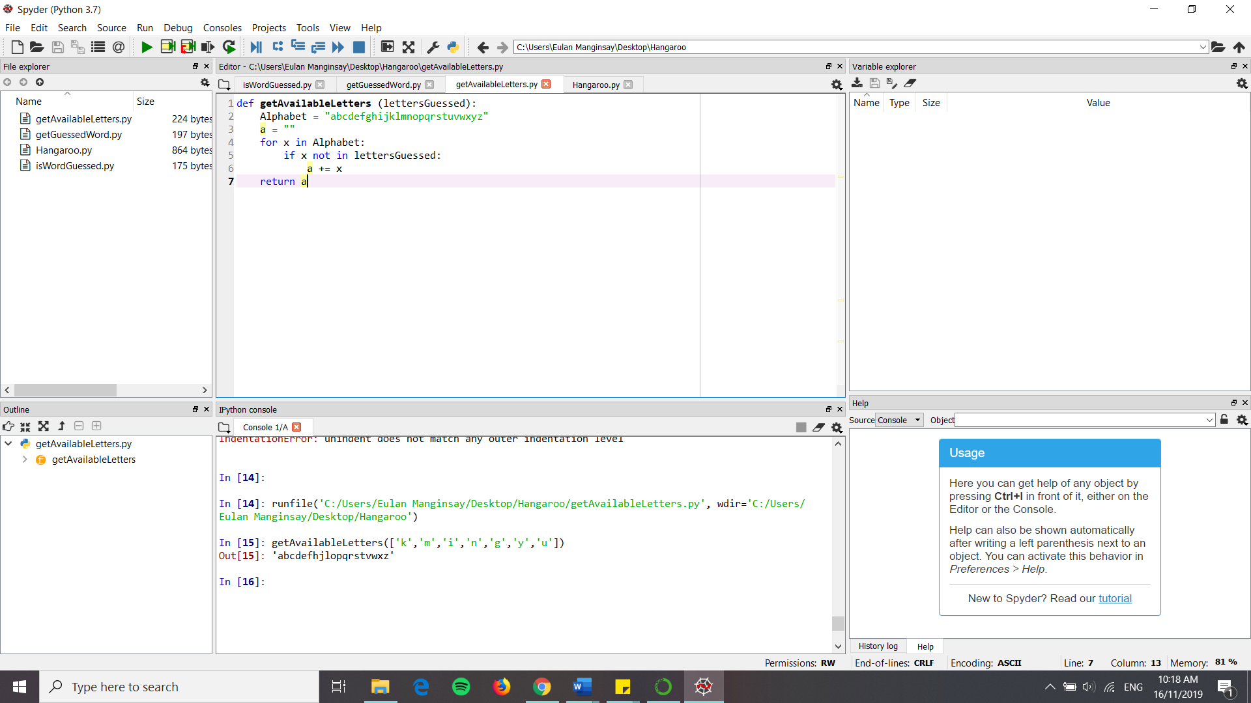

4. Hangaroo

